VS Code Assignment

Shopping Cart Unit Testing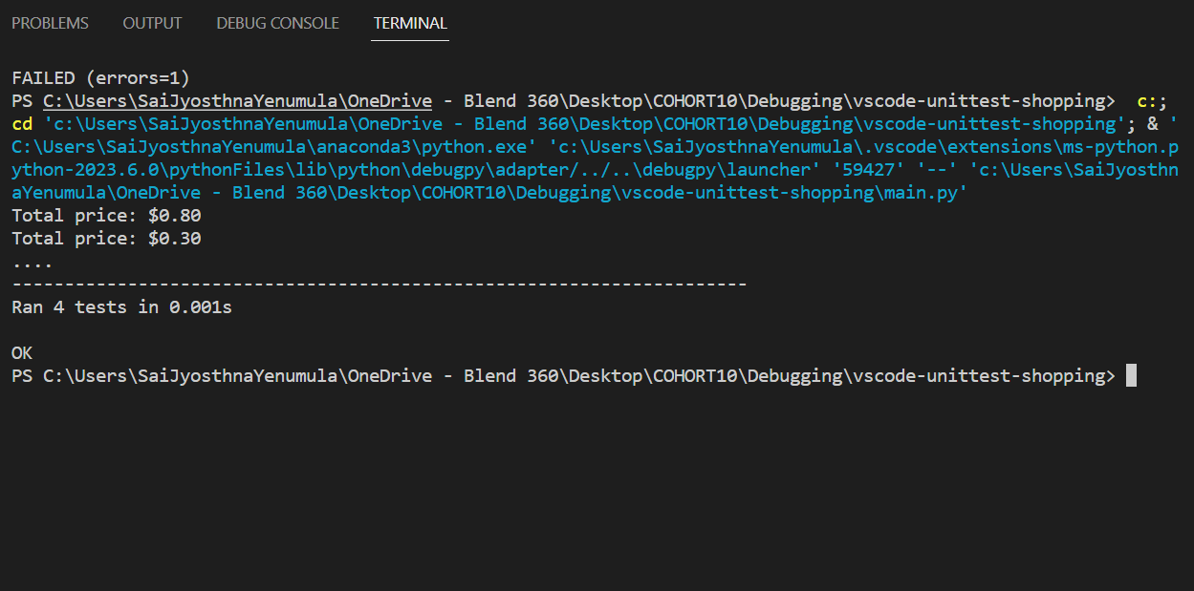

Extensions used:

Python and Pylance. With these we also get debugging, unit tests, Jupyter notebook extensions etc.



